Physics 20 Lesson 28

Simple Harmonic Motion – Dynamics & Energy

Now that we have learned about work and the Law of Conservation of Energy, we are able to look at how these can be applied to the same phenomena. In general, we use the method of **dynamics to solve for forces and accelerations**, and we use **energy conservation when we are asked to solve for speeds, displacements and heights**. In this lesson we will revisit simple harmonic motion (pendulums and vibrating horizontal springs) and will apply our knowledge of dynamics and energy conservation.

# The Pendulum – Dynamics

We can understand the motion of a pendulum as an application of the dynamics or as an energy system. Consider a pendulum mass (also called a “bob”) that is initially hanging in the equilibrium position. Note that Fg equals FT and the net force is zero. In addition, the total mechanical energy for the pendulum is also zero (i.e. no potential and no kinetic energy).



We then move the mass from its equilibrium position through an angle  and then release it. As the force diagram to the right indicates, FT no longer opposes Fg. Recall from our work with inclined planes in Lesson 17 that on an incline the normal force acts at an angle to the force of gravity. We broke up the force due to gravity (Fg) into two components (Fx and Fy). We do the same thing here and resolve the force of gravity into components. Note that the perpendicular component of gravity (Fy) is equal and opposite the tension force (FT). The result is a restoring force (Fx) that acts toward the equilibrium point.

❑



❑



Therefore, the bob accelerates toward the equilibrium point and the bob gains speed. But **the acceleration is not uniform** – as the angle  becomes smaller the restoring force becomes smaller until at the equilibrium point the acceleration is zero. At the equilibrium point the bob has reached its maximum speed. As it passes through the equilibrium point, the restoring force now acts to slow the bob down. (For a detailed description of the dynamics of a pendulum swing see Pearson page 360.)

It is very important to note that since the acceleration is not uniform one can not use equations like

 or 

to calculate speed. Such equations assume uniform acceleration. To deal with non-uniform acceleration requires the use of either integral calculus, which you will learn about in Mathematics 31, or you can apply the principle of conservation of mechanical energy.

Determine the acceleration of a 0.250 kg pendulum bob as it passes through an angle of 16o to the right of the equilibrium point.

❑



❑

First calculate the restoring force.



Calculate the acceleration using Newton’s 2nd Law



# The Pendulum – Mechanical energy

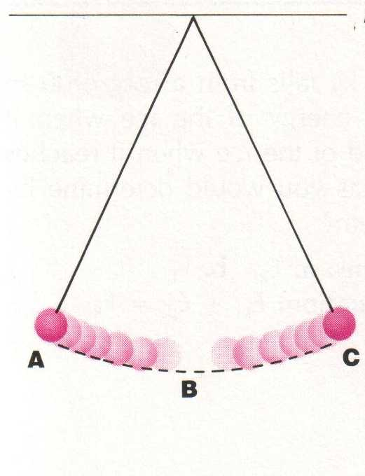We can also understand the motion of a pendulum as an example of the conservation of mechanical energy. When a pendulum is pulled to the side (position A), the pendulum has gravitational potential energy – i.e. point A is higher than B. When the pendulum is released, the gravitational potential energy is transformed into kinetic energy until all of the gravitational potential energy is converted into kinetic energy at the bottom of the swing (position B). The pendulum keeps swinging through the equilibrium position, losing kinetic energy as it regains gravitational potential energy. Assuming that there is no loss to heat or friction, it will rise to a point equal to the original height above the equilibrium position (position C). At the top of the swing the pendulum is instantaneously at rest (Ek = 0) and all of the energy is in gravitational potential form. Then it will begin to swing back toward the equilibrium position.

The figure below is a graph of the changing gravitational potential and kinetic energies of a pendulum bob during one-half of an oscillation. Note that the sum or total (Ep + Ek) of the kinetic and gravitational potential energies is constant.

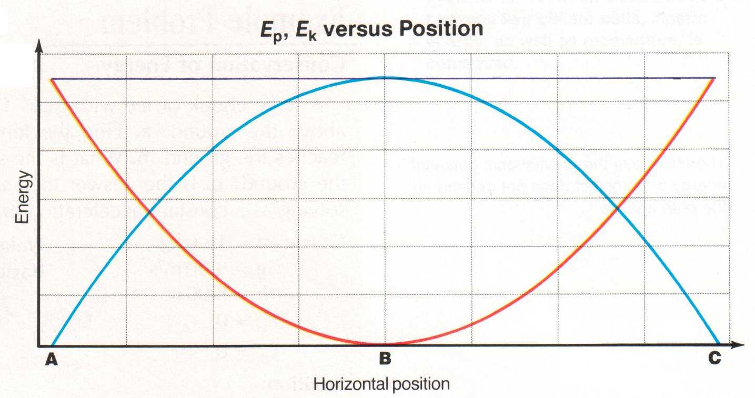

Ep

Ek

Ep + Ek

Throughout its motion a pendulum has a combination of kinetic and gravitational potential energies. Thus at **any point** the total mechanical energy of the pendulum is equal to:

Etotal = Ep + Ek

Etotal = m g h + ½ m v2

At the top of the swing (hmax) the pendulum has no kinetic energy (Ek = 0). It has gravitational potential energy only. Thus

Etotal = Ep max = m g hmax

At the bottom of a swing (vmax) the total mechanical energy is kinetic only. Thus

Etotal = Ek max = ½ m vmax 2

(For a different description of the mechanical energy of a pendulum see Pearson pages 314 to 316.)

A 2.0 kg mass on a string is pulled so that the mass is 1.274 m higher than at the equilibrium point. When it is released:

A. What is the maximum speed that the pendulum will have during its swing?



B. What is the speed of the pendulum when it is half way down from its maximum height?



# Horizontal Vibrating Springs – Dynamics

Like the pendulum that we discussed above, we can understand the motion of a mass-spring system as an application dynamics. Consider a horizontal mass-spring system as shown to the right. If the mass-spring system is compressed to the left a restoring force is produced to the right resulting in an acceleration toward the equilibrium point. The acceleration may be calculated using a combination of Hooke’s Law and Newton’s 2nd Law of motion.

equilibrium point



m



equilibrium point



m

v

As the mass moves toward the equilibrium point, the restoring force and acceleration decrease while the speed increases. As the mass moves through the equilibrium point, no compression or tension exists in the spring. Therefore, the restoring force and acceleration are zero when the speed is at a maximum.

Once the mass passes beyond the equilibrium point the spring begins to stretch resulting in a negative restoring force and acceleration toward the equilibrium point. The mass slows down until it comes to a stop and then moves toward the left. (For a detailed description of the dynamics of a mass-spring system see Pearson pages 354 and 355.)

equilibrium point



m

Note the negative sign in the acceleration equation above. If the mass is given a positive displacement (+x) the resulting acceleration is negative, and if the mass is given a negative displacement (­–x) the resulting acceleration is positive. In other words, the restoring force and therefore the resulting acceleration, is always toward the equilibrium point of the system.

Like the acceleration of a pendulum, the acceleration of a mass-spring system is not uniform. Thus, in order to calculate the speed of the mass at any given point we need to apply the principle of conservation of mechanical energy.

A 0.724 kg mass is oscillating on a horizontal frictionless surface attached to a spring (k = 8.21 N/m). What is the mass's displacement when its instantaneous acceleration is 4.11 m/s2 [left]?



# Horizontal Vibrating Springs – Mechanical energy

A vibrating horizontal mass on a spring is very similar to a pendulum. When the spring is at rest at its equilibrium position it will have no energy. However, displacing the mass from the equilibrium point gives the spring potential energy. When the mass is released, the spring potential is converted into kinetic energy. In turn the kinetic energy is converted into spring potential, which in turn is converted into kinetic energy and so on. Like a pendulum, a weighted vibrating spring has constant total energy. At any point the total energy is given by:

Etotal = Ep + Ek

Etotal = ½ k x2 + ½ m v2

At the ends of its vibration the displacement is at a maximum (xmax) and the system is instantaneously at rest. Thus

Etotal = Ep max = ½ k xmax2

At the equilibrium point (x = 0) the total mechanical energy is kinetic only (vmax). Thus

Etotal = Ek max = ½ m vmax2

A 0.40 kg mass vibrates at the end of a horizontal spring along a frictionless surface. If the spring’s force constant is 55 N/m and the maximum displacement (amplitude) is 15 cm, what is the maximum speed of the mass as it passes through the equilibrium point?



# Practice problems

1. A pendulum bob (m = 250.0 g) experiences a restoring force of 0.468 N. Through what angle is it displaced? (11.0o)

2. A 0.50 kg pendulum is pulled back and released. When the height is 0.60 m above its equilibrium position its speed is 1.9 m/s. What is the maximum height of the pendulum? (0.78 m)

3. A 2.60 g mass experiences an acceleration of 20.0 m/s2 at a displacement of 0.700 m on a spring. What is k for this spring? (0.0743 N/m)

4. A mass vibrates at the end of a horizontal spring (k = 125 N/m) along a frictionless surface reaching a maximum speed of 7.0 m/s. If the maximum displacement of the mass is 85.0 cm, what is the mass? (1.84 kg)

# Hand-in assignment

1. Why is the acceleration of a simple harmonic oscillator not uniform?

2. Describe the positions that a mass-spring system and pendulum are in when:

(a) acceleration is a maximum

(b) velocity is a maximum

(c) restoring force is maximum

3. Determine the restoring force of a pendulum that is pulled to an angle of 12.0° left of the vertical. The mass of the bob is 300.0 g. (0.612 N [right])

4. At what angle must a pendulum be displaced to create a restoring force of 4.00 N on a bob with a mass of 500.0 g? (54.6°)

5. A 1.35 kg pendulum bob is hung from a 3.20 m string. When the pendulum is in motion its speed is 2.40 m/s when its height is 85.0 cm above the equilibrium point. What is the maximum speed of the pendulum? What is the period of vibration for the pendulum? (4.74 m/s, 3.59 s)

6. A 2.50 kg pendulum bob is hung from a 2.75 m string. The pendulum is pulled back and released from a height h above the equilibrium point. If its maximum speed is 6.26 m/s what is h? What is the period of vibration for the pendulum? (2.00 m, 3.33 s)

7. Tarzan swings on a 30.0 m long vine initially inclined at an angle of 37.0° from the vertical. What is his speed at the bottom of the swing if he does the following?

a. starts from rest (10.9 m/s)

b. pushes off with a speed of 4.00 m/s (11.6 m/s)

8. For each situation below, draw accurate free-body diagrams showing all forces acting on the rock.

b. Suspended from a spring. Instantaneously at rest at the top of its travel.

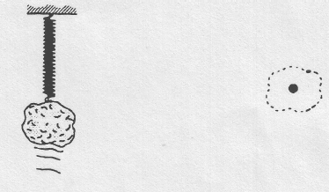

a. Suspended from a spring. Pulled downward slightly and released. No friction.

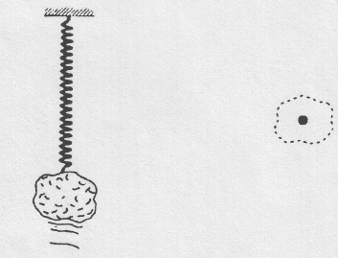

d. Suspended from a spring. Moving upward through the equilibrium position. No friction.

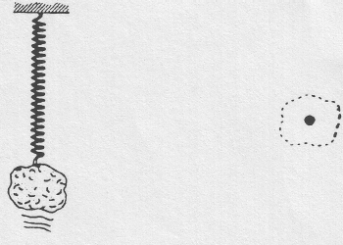

c. Suspended from a spring. Moving downward through the equilibrium position. No friction.

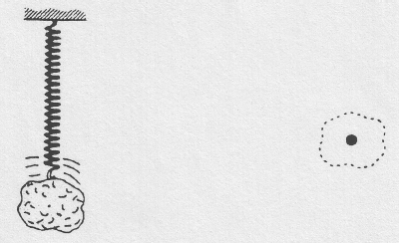

9. A mass of 3.08 kg oscillates on the end of a horizontal spring with a period of 0.323 s. What acceleration does the mass experience when its displacement is 2.85 m to the right? (1.08 x 103 m/s2 [left])

10. A 4.0 kg mass vibrates at the end of a horizontal spring along a frictionless surface reaching a maximum speed of 5.0 m/s. If the maximum displacement of the mass is 11.0 cm, what is the spring constant? (8.3 x 103 N/m)

11. An object vibrates at the end of a horizontal spring, spring constant = 18 N/m, along a frictionless horizontal surface. If the maximum speed of the object is 0.35 m/s and its maximum displacement is 0.29 m, what is the speed of the object when the displacement is 0.20 m? (0.25 m/s)

12. A 0.750 kg object vibrates at the end of a horizontal spring (k = 995 N/m) along a frictionless surface. The speed of the object is 2.50 m/s when its displacement is 0.145 m. What is the maximum displacement and speed of the object? (0.160 m,

5.84 m/s)

13. A mass of 2.50 kg is attached to a horizontal spring and oscillates with an amplitude of 0.800 m. The spring constant is 40.0 N/m. Determine:

a) the acceleration of the mass when it is at a displacement of +0.300 m (–4.80 m/s2)

b) the maximum speed (3.20 m/s)

c) the period (1.57 s)

14. A horizontal mass-spring system has a mass of 0.200 kg, a maximum speed of 0.803 m/s, and an amplitude of 0.120 m. What is the mass's position when its acceleration is 3.58 m/s2 to the west? (0.0799 m [east])

15. An object vibrates at the end of a horizontal spring, k = 18 N/m, along a frictionless horizontal surface. If the maximum speed of the object is 0.35 m/s and its maximum displacement is 0.29 m, what is the speed of the object when the displacement is 0.20 m? (0.25 m/s)